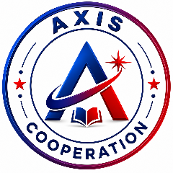
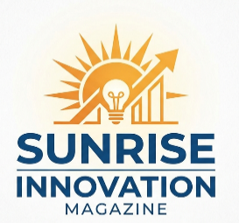
AXIS COOPERATION LTD
P.O.BOX 10830 KAMPALA
Tel: 0701-087-267 / 0788-340-949
Email: axiscooperation@gmail.com

Terms of Reference (ToR)

HIGHER EDUCATION & SCHOLARSHIP PARTNERSHIP
Document Purpose: Institutional Collaboration Framework
Project: Sunrise Innovation Magazine
Target Audience: Universities, Tertiary Institutions, and Scholarship Bodies in Uganda
Publication Cycle: 2026-2027 Academic Year Edition.

Context & Purpose
The Sunrise Innovation Magazine is a national educational initiative in Uganda dedicated to showcasing student-led scientific innovations, technology projects, and academic excellence in secondary schools.
To bridge the gap between secondary education and higher learning, this partnership framework enables universities, vocational institutes, and scholarship organizations to directly inform, enrol, and mentor secondary school students across Uganda.

Partnership Objectives
- Promote Access to Higher Education: Provide secondary school learners (S.1-S.6) with verified information regarding admission, degree and diploma programs, and financial aid.
- Showcase Scholarship Opportunities: Highlight merit-based, and STEM-focused scholarship schemes directly to qualifying students.
- Enhance Career Guidance: Deliver authoritative advice from university faculty on emerging market trends, career choice, and entry requirements.
- Support Youth Innovation: Align higher education institutions with secondary-level STEM and creative projects, fostering continuous talent development.

Scope of Collaboration & Deliverables
- Responsibilities of the Participating Institution
- Content Provision: Supply accurate, up-to-date information regarding available courses, admission criteria, fee structures, and scholarship application deadlines.
- Article & Feature Contribution: Provide high-resolution institutional logos, campus imagery, and optional career guidance write-ups authored by admissions officers or faculty members.
- Point of Contact: Designate an official institutional coordinator (e.g., Admissions Officer, Public Relations Officer) to liaise with the magazine’s editorial team.
- Review & Sign-Off: Review and approve the final institutional page proofs to press printing and digital release.
- Responsibilities of Sunrise Innovation Magazine
- Editorial and Layout Design: Design professional, high-impact page layouts incorporating the institution’s branding and colour scheme.
- Targeted Distribution: Distribute printed and digital copies of the magazine directly to secondary school headteachers, career guidance departments, science clubs, and school libraries across Uganda.
- Digital Amplification: Highlight featured scholarship opportunities across the magazine’s official digital channels and web portal.
- Quality Assurance: Ensure that all accompanying student features and editorial content maintain high educational and ethical standards.

Institutional Feature Options & Allocation
Feature Package | Page Allocation | Key Deliverables included
Scholarship & Admission Spotlight | 1 Full Page | Detailed Coverage of available scholarships, eligibility criteria, application process, key dates, and contact channels
Higher Education & Career Partner | 2-Page Spread | Full page for scholarship, admissions details plus 1 full page dedicated to a guest article on career guidance or emerging field trends.
Category Lead & Awards Sponsor | Multi-Page + Branding | Sponsorship of a specific student innovation award category (e.g., Best Secondary ICT Project), featuring institutional branding on award pages

Guiding Principles & Ethics
- Accuracy & Transparency: All details regarding entry requirements, fees, and scholarship terms must be clear, transparent, and non-deceptive.
- Child Protection & Data Privacy: Student inquiries generated through the magazine will be handled in compliance with national data privacy standards and school communication protocols.
- Non-Exclusivity: Participation does not grant exclusive sponsorship unless explicitly agreed upon under a specialized headline partnership contract.

Timeline & Key Milestones
Milestone | Date
Partnership Confirmation
Submission of Institutional Materials & Logos
Page Proof Review & Sign-Off
National Distribution & Circulation

Governance & Institutional Sign-off
These Terms of Reference are administered by the Sunrise Innovation Magazine Project Secretariat, however, they are subject to revision, as may be requested by a partnering institution from time to time to meet a convenient mode of partnership with this project which shall incentively comply with the major objective the project.
MANAGEMENT

